**Course Project - Warehouse Case Study**

Shaun Pritchard

Rasmussen College

QMB4900

James Grooms

January 16, 2021

**Course Project - Warehouse Case Study**

In this analysis I will aim to answer several business questions based on Supper Shoppers Reorder Points. I hope to solve the following business questions below.

**Business Question to Answer:**

* Why are Super Shoppers running out of best-selling products having to backorder stock of them?
* Why are slower selling products not being sold and reaching their expiration data?

In order to understand this, we will need to analyze the data to present informed business intelligence using Supper Shoppers store and warehouse data sets. I will also need to break down the warehouse reordering process to communicate best results.

**Point of reorder Process:**

Each outlet provides the warehouse with a weekly listing of in-store inventories and expired products. If **item counts** are less (<=) than or equal to the **reorder point**, distribution takes place accordingly.

* The warehouse logs and destroys all store returns of expired products.
* The warehouse clerk conducts a weekly inventory and submits an order for products that are less or equal to the warehouse **reorder point.**

This order flows through accounting, and once funding is approved, the order passes to the company buyers. At this point, the company buyers submit a purchase order to the appropriate vendor. The vendors usually ship most items the day after receiving purchase orders. As follows:

**Reorder Point Flowchart:**

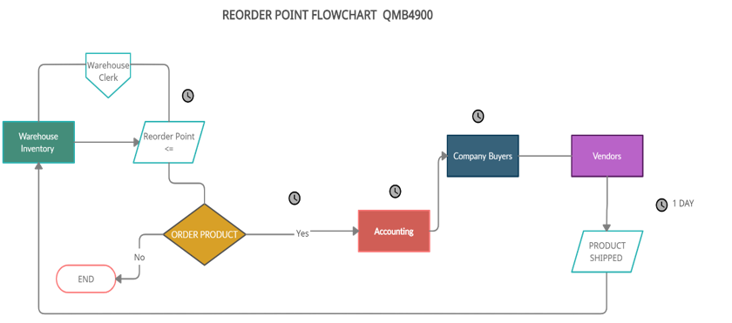

The only period we have through this process is the time it takes for the product to be shipped after the order is established from the warehouse clerk’s implementation of the **reorder point.**

**Business Hypothesis:**

* It could be applicable that the process itself plays a role in the bestselling products being on backorder.
* It could be possible the warehouse is experience inefficiencies or over ordering less-best-selling products being the case Super Shoppers has over amount of inventory that expires?

**Business Intelligence:**

After viewing the data, I was able to distinguish a few characteristics that facilitate the issues at hand. For this analysis we are going to look at the Weekly Inventories of all 10 stores and compare the gross number of products sold out to total average using Tableau. After reviewing the data, I seen there was no distinct date/time features aside from the 8-week blocks given the data. There for the issues we are trying to resolve will be based on product reorder point and stock.

* If fast selling products have a higher reorder point, I will have to lower it to meet demand and have an amount on stock or being ordered to prevent backorder.
* If overstocked products that are expiring this could mean reorder points are too low, there for over stocking products that do not sell efficiently
* I will also need to look at inventory amounts. Those with lower inventory amount may be best selling products running out. There for I will need to increase the stock amount.
* Again, if stock amounts are to high this could lead to overstock of products being ordered to soon during the reorder point.

First, I allocated all the data by combining all the store data to get an average visual of the products to tell which products were out of stock and those still in stock compared to those under a median range of 50%. I also added a summarized each individual table and made individual sheets for each store and each category of warehouse products which I combined in a story and dashboard while also using tables and descriptive statistics to verify the data.

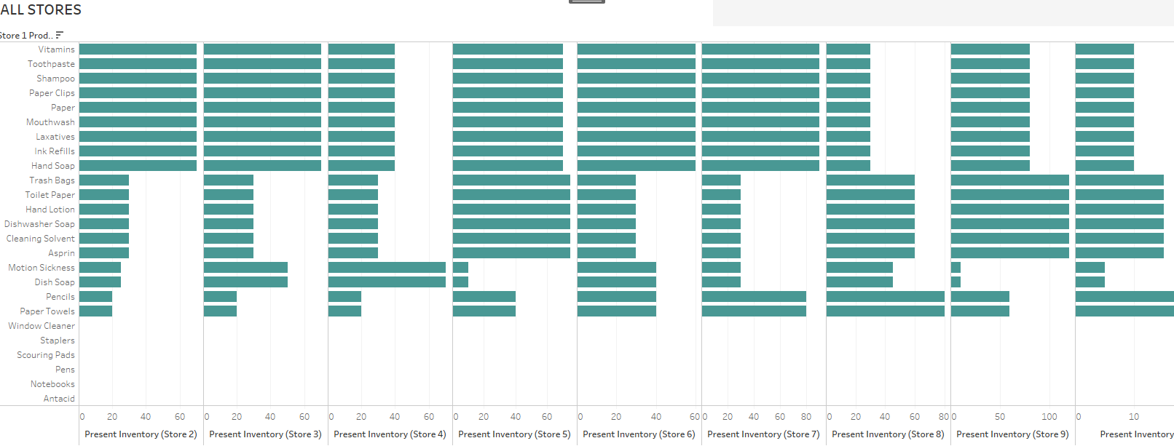

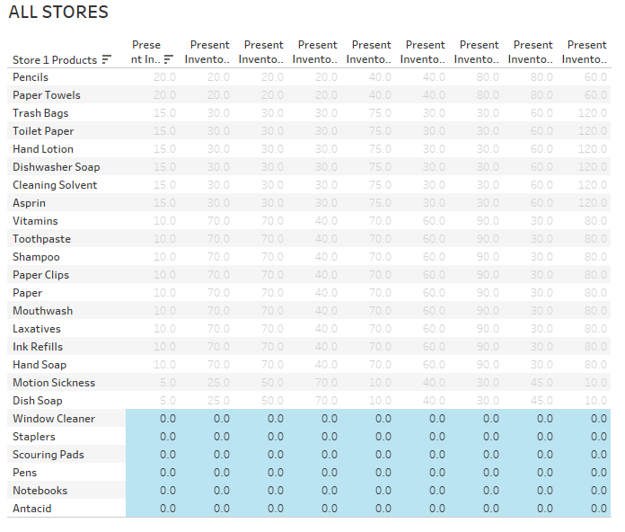

* We can see on average that window cleaner, staplers, scouring pads, pens, notebooks, and antacids are the products that are completely sold out this suggest they are most popular products.
* We can also see that Vitamins, toothpaste, shampoo, Paper clips, mouthwash, laxatives, ink refills and hand soap are still in stock from 75% to 100% not being sold as frequent.
* We can see that on average products like aspirin, Cleaning solvent, dishwasher Soap, hand lotion, are in stock at least 50% time or more.

The data also shows us that several stores are running out of products before other stores such as Store-2 and Store-4 with the least number of products in 8 weeks’ time period.

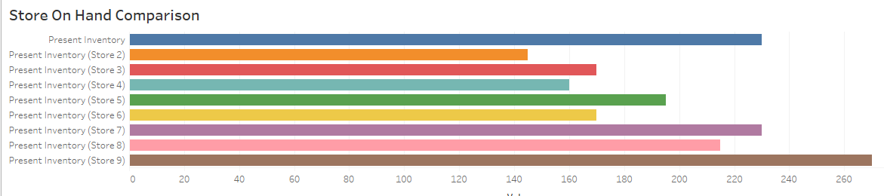

Store 2 data shows us product inventory from vitamins down at less than 5 products are left while products such as window cleaner and aspirin are completely gone and out of stock before the 8-week period.

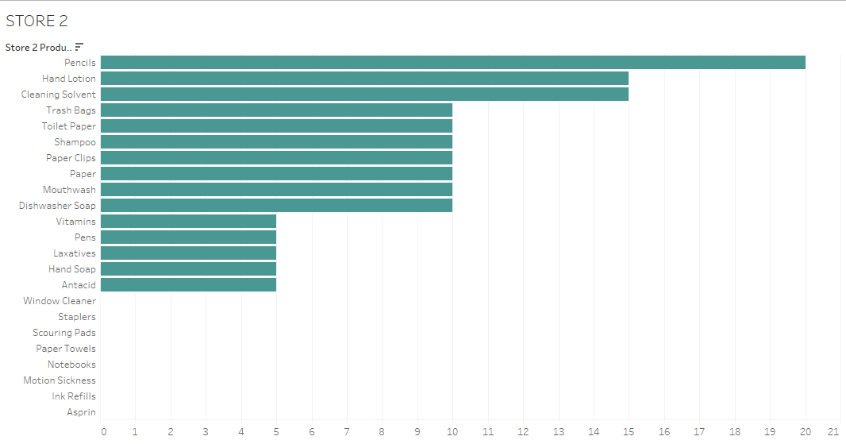

**Store 2 descriptive statistics:**

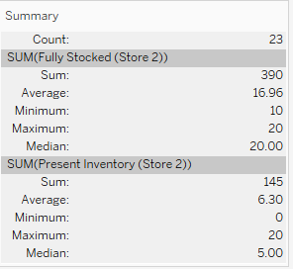

We can use the tree map to visualize the products which being sold out and other inventory at risk of being sold out in **Store-2**:

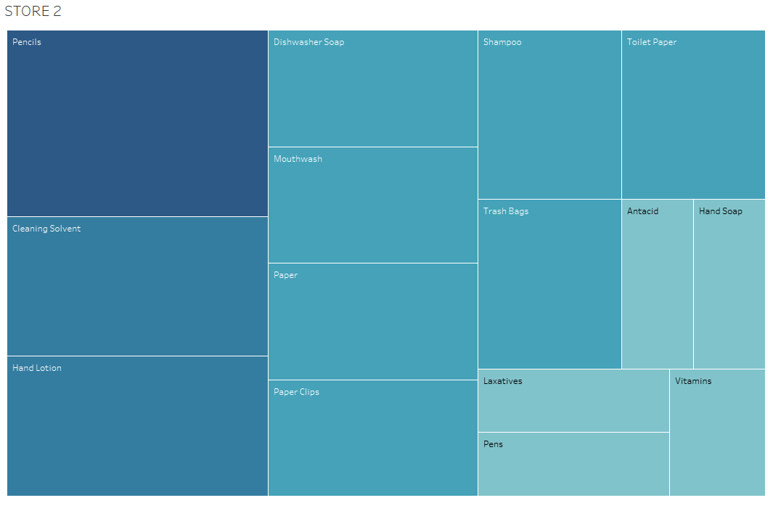

Pencils, Cleaning Solvent, and hand lotion are the most viable products. I assume these products are at risk of expiration. Even though it was never specified what types of products would have expiration dates such as non-food items and/or products.

From this data we now have a basis for which items to look at simply looking at sorted excel data we can see that in **Store-2** by the end of week1 products such as Window cleaner, paper towels hand soap, motion sickness medicine, and ink refills are completely gone.

We can see that fully stocked window cleaner is at 20 items stocked. If this is how many stocked items sell in one week, I would recommend stocking 160 to 170 units and marking a reorder point at 50 % of the stock amount. This is based off summing the 20 product units are sold at a frequncy1 week times 8 weeks.

We can use this same principle for the other products in the store as well if we apply this estimate as follows.

|  |  |  |  |
| --- | --- | --- | --- |
|  | Current Inventory | 8-week Inventory |  |
| Window Cleaner | 20 | 160 |  |
| Paper Towels | 20 | 160 |  |
| Toothpaste | 20 | 160 |  |
| Hand Soap | 20 | 160 |  |
| Toilet Paper | 20 | 160 |  |
| Motion Sickness | 10 | 80 |  |
| Ink Refills | 10 | 80 |  |

Super Shoppers also need to look at the distribution the orders sold out products take to go through the above process before the products are returned to the where house and available for new inventory. Unfortunately, we do not know the length of time Supper Shoppers takes to get the purchase order from the warehouse through accounting to the company buyer.

Super Shoppers can however look at the warehouse inventory to determine the amount of stock inventory and the reorder point. By changing the amount of stock items or the frequency for reorder point we could allocate a sufficient number of products to the store, so they do not run out. Also, we can look at the product which are nearly fully in stock in stores and determine if reorder point is ordering the less selling product more frequently than it should . This would reduce dimensionality of the warehouse and would save time in money on the front end of the business from being overstocked on product it does not sale that often.

I have broken down the warehouse inventory into the respected tables categories for specific products as follows.

* Bathroom Products
* Kitchen Products
* OTC Medicine
* Office products

Before making visualization, I cleaned the data and tabled it to work with and get valid results as follows.

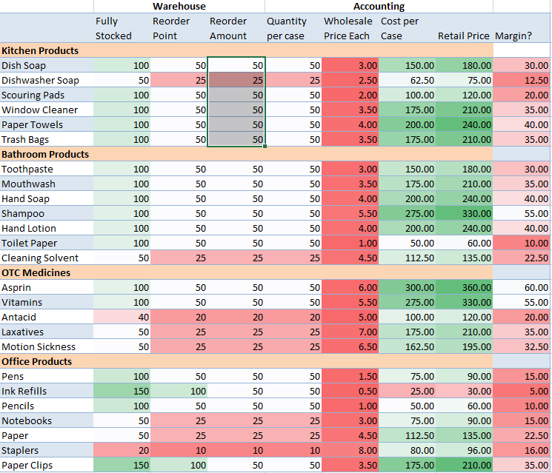

**Why are slower selling products not being sold and reaching their expiration data?**

This data shows us without visualization that Super Shoppers is keeping to much stock on products like pencils, ink refills, that do not sell that often when in fact Cleaning solvents sales at frequent amount while only having 50 units in stock. For ink refills once Super Shoppers get down to 100 units, they can order 100 more. This is inefficient, Super Shoppers could lower the stock and reorder point on other items as the visualizations show us such as pencils, and paper clips. Items most likely to expire would be OTC medicines food product, and some non-food products. I would recommend lowering the stock amount or raising the reorder point for those items plus toothpaste, mouthwash, laxatives, and shampoo. As these are products that are most likely to go to waste from over stocking

**Why are we running out of best-selling products having to backorder stock of them?**

We can see Super Shoppers is running out of best selling products as mention because the reorder points are all to high at 100 or above while not facilitating enough stock to replenish the products before they run out within the 8 week period of time. These visualizations below of the warehouse categories and the chart data to come to this determination.

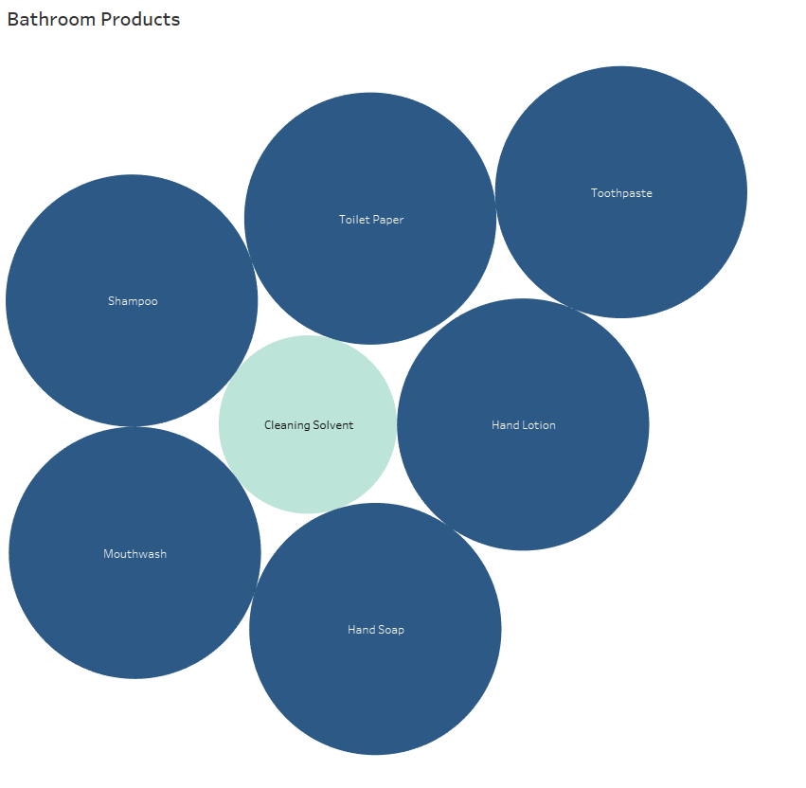

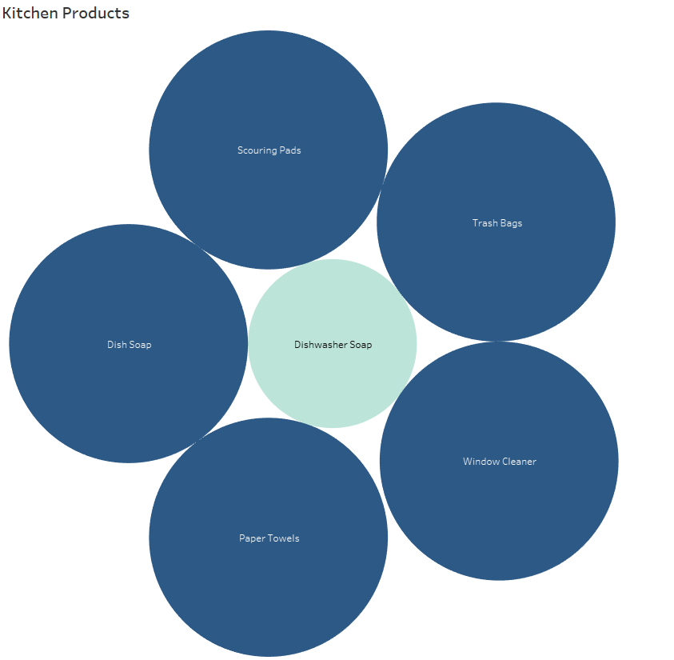

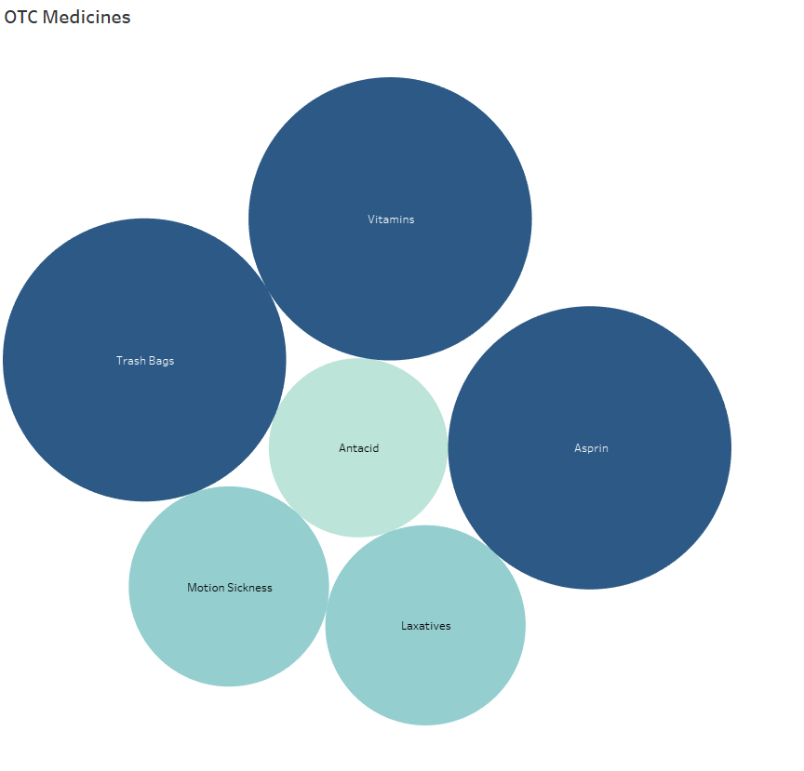

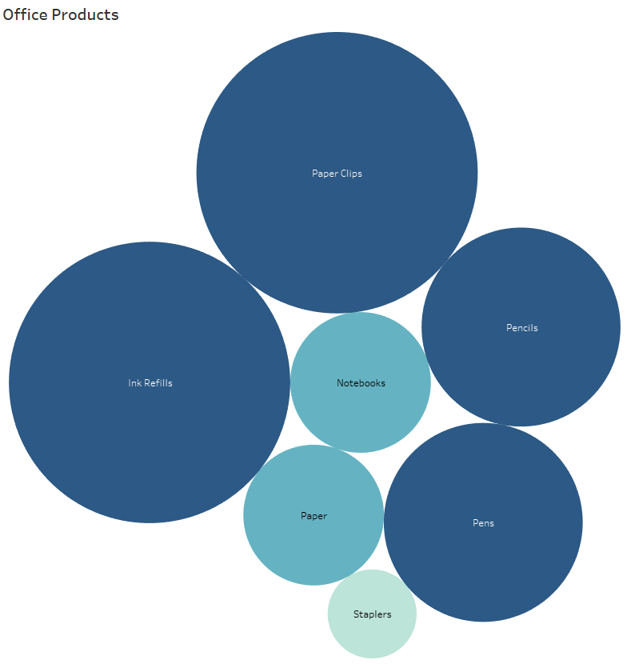

This data shows us that these specific products have a low reorder point compared to the reorder amount using packed bubble charts. We can see the variance between items have plenty of stock for and those compared to the same items that are running out of being short.

Essentially, Super Shoppers need to re-evaluate these items and adjust to number of products Super shoppers will have in stock to facilitate their demand for them. Also, lowering reorder points will allow for faster orders being procced so best-selling products are always on hand. Again, I will mention I have no distinct timeline as to the completion or estimate of the process as specified in the flowchart. This could very well be an internal problem, but there is no way to tell without the data.